WEEK 8
GIT
- Git-HOL

# Step 1: Setup Git configuration
git --version
git config --global user.name "Your Name"
git config --global user.email "your.email@example.com"
git config --list

# Step 2: Integrate Notepad++ as default editor (assuming path is already set)
alias npp="notepad++.exe"
git config --global core.editor "notepad++.exe"

# Step 3: Create and initialize a repository
mkdir GitDemo
cd GitDemo
git init
ls -a

# Create a file and add content
echo "Welcome to Git!" > welcome.txt
cat welcome.txt

# Stage and commit the file
git status
git add welcome.txt
git commit -m "Add welcome.txt with greeting message"

# Create remote repo (done on GitLab) and link it
git remote add origin <REMOTE_REPO_URL>

# Sync with remote
git pull origin master
git push origin master

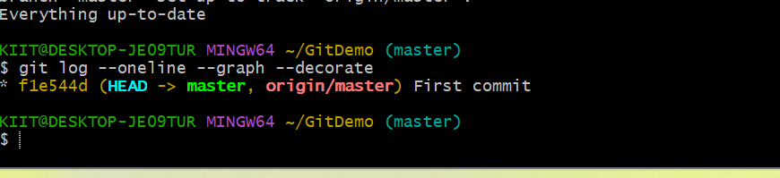

- Git-HOL

# Create .log file and log folder
echo "This is a log file" > debug.log
mkdir logs
echo "Log entry" > logs/app.log

# Create .gitignore file
echo "*.log" > .gitignore
echo "logs/" >> .gitignore

# Verify
git status

# Stage and commit .gitignore
git add .gitignore
git commit -m "Add .gitignore to ignore .log files and logs folder"

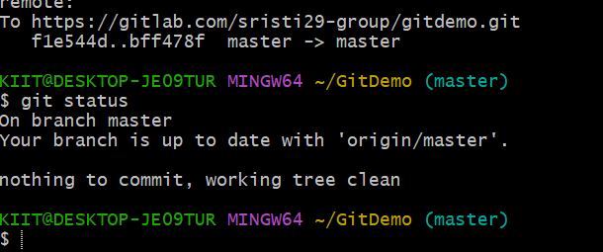

- Git-HOL

# Create a new branch
git branch GitNewBranch
git branch -a
git checkout GitNewBranch

# Add file in new branch
echo "Content in new branch" > branchfile.txt
git add branchfile.txt
git commit -m "Add branchfile.txt in GitNewBranch"
git status

# Switch to master
git checkout master

# Compare changes
git diff master GitNewBranch

# Merge GitNewBranch into master
git merge GitNewBranch

# View commit graph
git log --oneline --graph --decorate

# Delete branch after merge
git branch -d GitNewBranch

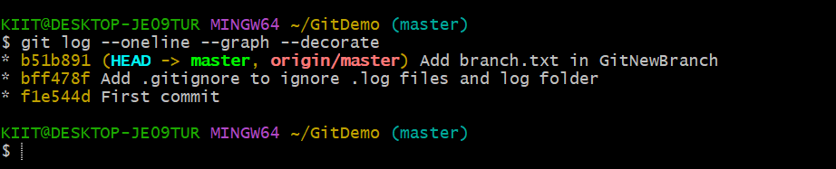

- Git-HOL

# Create branch and add hello.xml
git checkout -b GitWork
echo "<message>Hello from branch</message>" > hello.xml
git add hello.xml
git commit -m "Add hello.xml in GitWork"

# Switch to master and add different hello.xml
git checkout master
echo "<message>Hello from master</message>" > hello.xml
git add hello.xml
git commit -m "Add hello.xml in master"

# Merge branch into master (conflict expected)
git merge GitWork

# Resolve conflict manually in editor (e.g., Notepad++)
# After resolving:
git add hello.xml
git commit -m "Resolve merge conflict in hello.xml"

# Add backup files to .gitignore
echo "*~" >> .gitignore
git add .gitignore
git commit -m "Ignore backup files"

# Delete branch
git branch -d GitWork

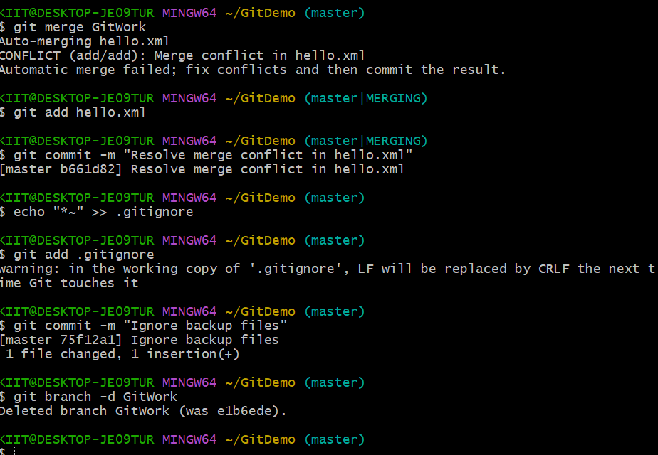

- Git-HOL

#Ensure master is clean
git status

# List branches
git branch -a

# Pull latest from remote
git pull origin master

# Push any pending changes
git push origin master

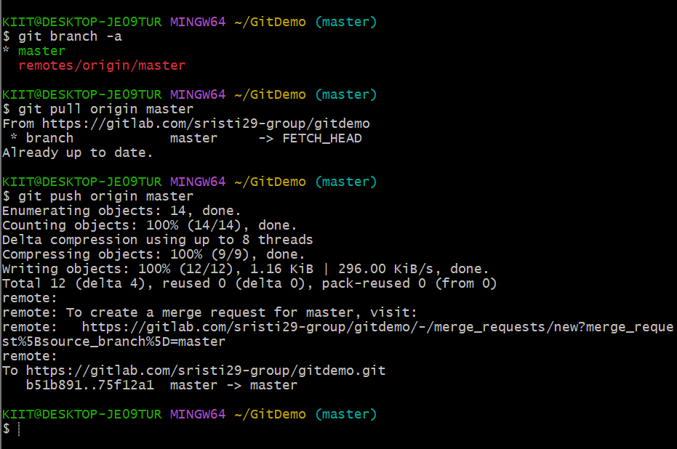

---------------------------------------------------------X---------------X-----------------------------------------------------------

